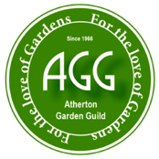
2024-2025 AGG DONATION FUNDING SUGGESTION
Barbara Tyler - Chair
Sue Connelly, Sue Matthews - Committee Members

Name of Organization:

Name & Title of Contact Person at Organization:

Address, Phone, and Email:

Please give a brief description of the purpose or work of the organization.

For what specific purpose will our donation be used?

Why do you feel AGG should support this organization?

Member’s Signature: Date:

Please return this form to Barbara Tyler by February 28, 2025. Thank you so much!
111 Yale Road, Menlo Park, CA 94025
Email: barbtyler@me.com Cell: 650-380-3646

